**SQL Capstone Project:**

**Product Analysis:**

-- Product lines with the highest revenue

SELECT P.Product_Line, SUM(S.Total) AS TotalRevenue

FROM Product P

JOIN Sales S ON P.Product_ID = S.Product_ID

GROUP BY P.Product_Line

ORDER BY TotalRevenue DESC;

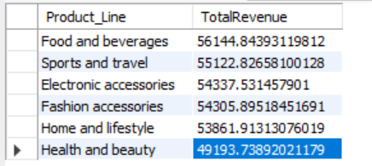

-- Total revenue generated each month

SELECT S.monthname AS Month, SUM(S.Total) AS MonthlyRevenue

FROM Sales S

GROUP BY S.monthname

ORDER BY MonthlyRevenue desc;

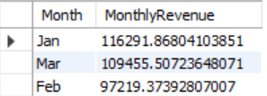

**Sales Analysis:**

-- City with the highest sales revenue

SELECT S.City, SUM(S.Total) AS CityRevenue

FROM Sales S

GROUP BY S.City

ORDER BY CityRevenue DESC

LIMIT 1;

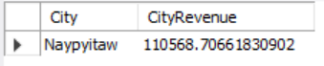

-- Most frequent payment method

SELECT S.Payment, COUNT(*) AS PaymentCount

FROM Sales S

GROUP BY S.Payment

ORDER BY PaymentCount DESC

LIMIT 1;

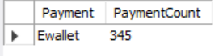

**Customer Analysis:**

-- Customer type contributing the highest revenue

SELECT C.Customer_Type, SUM(S.Total) AS TotalRevenue

FROM Customer C

JOIN Sales S ON C.Invoice_ID = S.Invoice_ID

GROUP BY C.Customer_Type

ORDER BY TotalRevenue DESC;

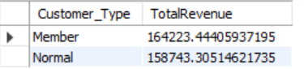

-- Average rating for each product line

SELECT P.Product_Line, AVG(C.Rating) AS AverageRating

FROM Customer C

JOIN Sales S ON C.Invoice_ID = S.Invoice_ID

JOIN Product P ON S.Product_ID = P.Product_ID

GROUP BY P.Product_Line

ORDER BY AverageRating DESC;

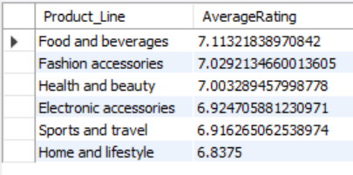

1. What is the count of distinct cities in the dataset?

Ans: 3

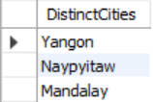

1. For each branch, what is the corresponding city?

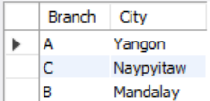

1. What is the count of distinct product lines in the dataset?



1. Which payment method occurs most frequently?



1. Which product line has the highest sales?

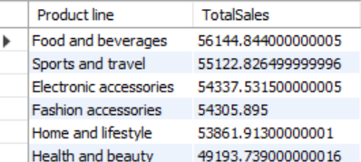

1. How much revenue is generated each month?

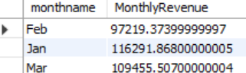

1. In which month did the cost of goods sold reach its peak?

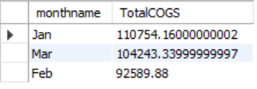

1. Which product line generated the highest revenue?

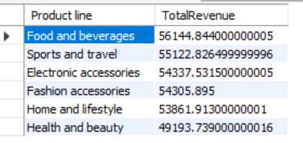

1. In which city was the highest revenue recorded?

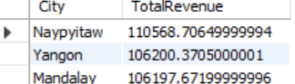

1. Which product line incurred the highest Value Added Tax?

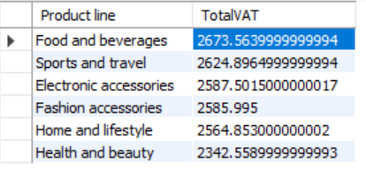

1. For each product line, add a column indicating "Good" if its sales are above average, otherwise "Bad."
2. Identify the branch that exceeded the average number of products sold.

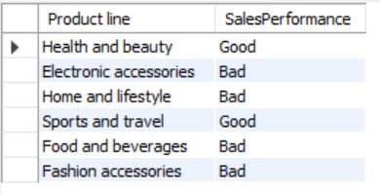



1. Which product line is most frequently associated with each gender?

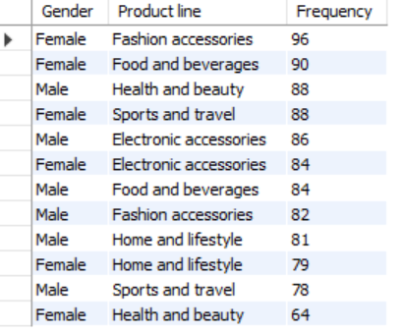 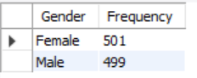

1. Calculate the average rating for each product line.

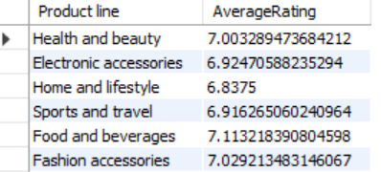

1. Count the sales occurrences for each time of day on every weekday.

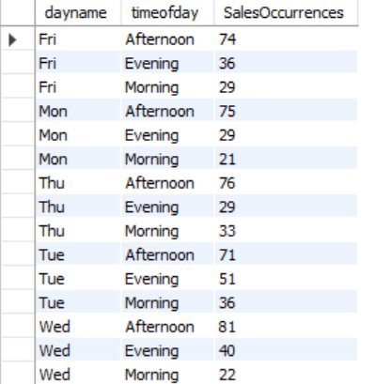

1. Identify the customer type contributing the highest revenue.

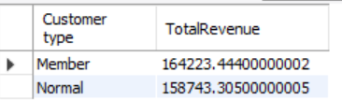 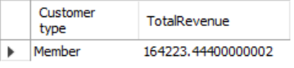

1. Determine the city with the highest VAT percentage.

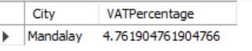

1. Identify the customer type with the highest VAT payments.

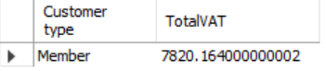

1. What is the count of distinct customer types in the dataset?

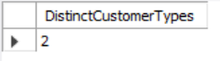

1. What is the count of distinct payment methods in the dataset?

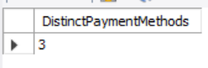

1. Which customer type occurs most frequently?

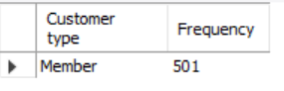

1. Identify the customer type with the highest purchase frequency.

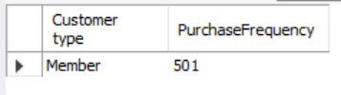

1. Determine the predominant gender among customers.

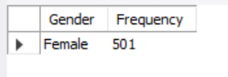

1. Examine the distribution of genders within each branch.

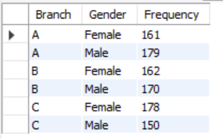

1. Identify the time of day when customers provide the most ratings.

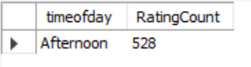 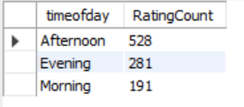

1. Determine the time of day with the highest customer ratings for each branch.

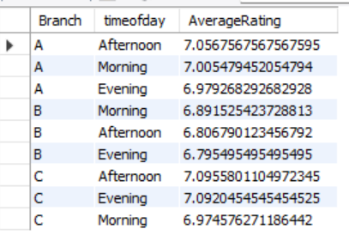

1. Identify the day of the week with the highest average ratings.

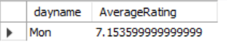

1. Determine the day of the week with the highest average ratings for each branch.

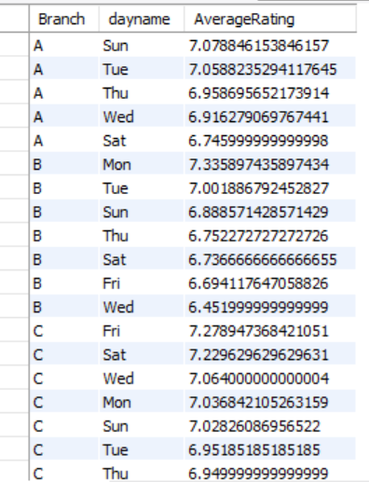

**Strategic Recommendations**

* **Product Line Improvement:** Focus on improving the product lines categorized as "Bad" to elevate overall performance.
* **Sales Strategy Optimization:** Given the high sales during the afternoon, consider promotional activities or staffing adjustments during these hours.
* **Branch-Specific Initiatives:** Tailor marketing and operational strategies based on the predominant customer type and gender distribution in each branch.
* **Leverage Digital Payments:** With Ewallet being the most frequent payment method, further promotions around this method could enhance customer convenience and satisfaction.